**Experiment 3 Paul Thomas 30 S3 CSB**

**Program**

| abstract class shape{  abstract void numberofsides();  }  class triangle extends shape{  void numberofsides(){  System.out.println("Number of sides of Triangle is 3.");  }  }  class rectangle extends shape{  void numberofsides(){  System.out.println("Number of sides of Rectangle is 4.");  }  }  class hexagon extends shape{  void numberofsides(){  System.out.println("Number of sides of Hexagon is 6.");  }  }  class abstractclassexp{  public static void main(String[]args){  triangle t = new triangle();  t.numberofsides();  rectangle r = new rectangle();  r.numberofsides();  hexagon h = new hexagon();  h.numberofsides();  }  } |
| --- |

Program

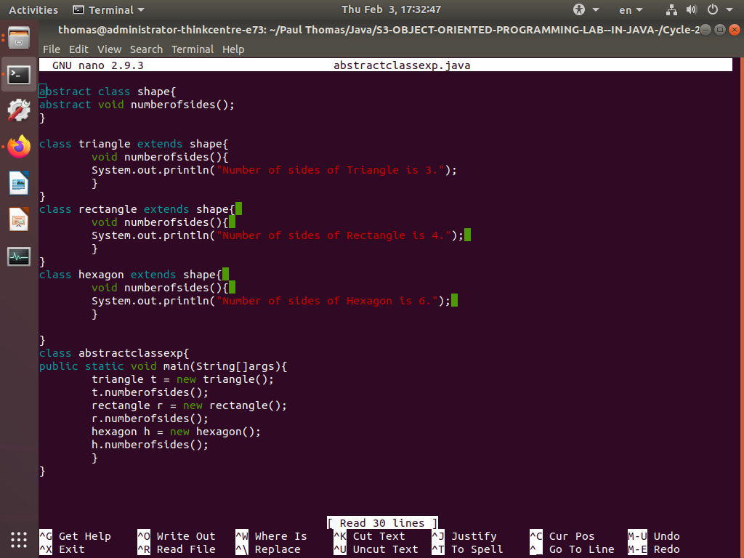

Output

